|  |  |
| --- | --- |
| Team ID | PNT2022TMID45523 |
| Project Name | Customer Care Registry |
| Maxmimum Marks | 4 Marks |

Project Design Phase -1

Solution Architecture:

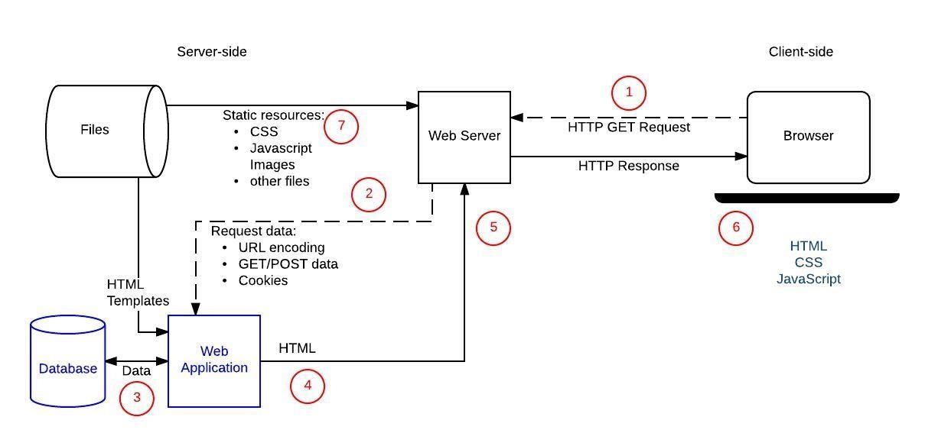

Solution architecture is a complex process – with many sub process that sub network bridges the gap between and business problem and technology solutions following goals are

* Describes the structures,characteristics ,behaviour and other aspect of the software ,stakeholder
* Find the best solution to solve existing business problems
* Define features
* Development phase
* Requirements solutions
* Provide specification according to which the solution is defined manage and delivered